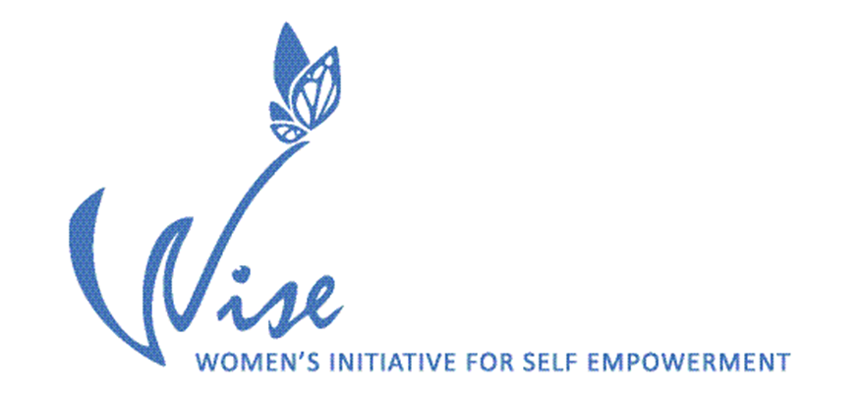

Job Description

Title: Executive Director
Reports to: Board of Directors
Time: Full-time – 32 hours/week; salaried
Schedule: M-Th 10:00 – 6:00, on rare occasions an evening or weekend
Salary: $99,750/annually
Benefits: Vacation - 96 hours/year, Sick leave - 64 hours/year, Personal holidays - 96 hours/year, Agency paid - Life Insurance $80,000, Short- and long-term disability insurance, and up to 11% of gross towards medical/dental insurance (individual policy selected by employee)
Deadline: Position will remain open until filled. Interviews will begin September 2, 2025
Apply: Send a cover letter, curriculae vitae/resume, professional writing sample (published article/grant proposal/funder report with a minimum of five single- spaced pages) to edhire@womenofwise.org Applications lacking any of the required submissions will not be considered.

Agency background:
WISE was created by a group of multicultural women in 1995. They came together to address the disparities in the treatment of immigrant women in terms of educational opportunities, employment, and career advancement. Over time the organization has continued to expand its understanding of the dynamics which hold-back immigrant and refugee women, girls and those on the feminine gender spectrum from achieving their full potential.

WISE’ mission is to support immigrant and refugee women, girls and those on the feminine gender spectrum in their journey of self-actualization through culturally-responsive education, advocacy, systems change and resource development.

WISE seeks an Executive Director with a proven track record of success in nonprofit/project management, fundraising and grant writing, fiscal management, program development, board relations, public speaking, and strategic planning. Capacity and skills to manage a $1M+ annual budget, meet required nonprofit legal and fiscal compliance, and effectively manage the day-to-day operations of the organization are essential components of this position.

Core Duties
- Actualize the mission of WISE and ensure the highest quality of services for the participants/communities it serves
- Be the face of the agency, speaking on behaf of WISE’ vision and critical role in the communities it serves
- Evauate the effectiveness of all programming and make adjustments as necessary in realizing the agency’s goals and objectives
- Hire, supervise and/or terminate staff
- Develop strong working relationships with funders and other strategic partners
- Oversee all aspects of fiscal management
- Oversee all grant administration duties, including but not limited to financial reporting, program progress reports, maintaining required governmental registrations and nonprofit status, filing annual audits/990s/annual reports, and monitoring progress toward meeting grant outcomes
- Develop and monitor internal operating procedures and policies
- Oversee human resource policy implementation
- Develop/evaluate/expand programs in collaboration with other staff and partners
- Develop and monitor annual fiscal year operating revenue and expense budget
- Identify new funding sources for WISE
- Generate proposals with accompanying budgets and attachments to meet WISE’ annual operating budget
- Staff board committees
- Meet monthly with board chair
- Attend weekly staff meetings, quarterly staff retreats and twice-yearly board-staff retreats
- Supervise and support staff in their professional development
- Enter into and monitor contracts with consultants/contract labor
- Ensure compliance with relevant nonprofit law

Time Distribution
60% of time overseeing fiscal management, billing and reporting
20% of time writing grants and prospecting for new funders
10% of time conducting staff/fellows supervision, and attending staff meetings and retreats
5% of time attending board and committee meetings and strategic planning
5% of time developing programs/strategic allliances and conducting trainings

Qualifications
- Bachelor’s Degree or higher in human services, women’s studies, education, youth leadership, social work, cultural studies, family social science, human rights, community education, or other related field
- Four years experience working in nonprofit management/project management;
- Three years experience working with immigrant/refugee families in the areas of social services/ housing/education/human rights/community organizing/ anti-oppression/domestic/sexual violence;
- Three years experience creating and managing budgets;
- Thorough understanding of profit & loss statements, balance sheets, cash flow projections, fund-based accounting;
- Experience working collaboratively with community organizations, schools, and youth;
- Understanding of social justice issues affecting immigrant and refugee communities;
- Experience and competencies in working in a multicultural immigrant/refugee environment;
- Strong organizational and time management skills;
- Commitment to positive youth development;
- Proficient in Microsoft applications: Word, Excel, PowerPoint;
- Strong leadership skills;
- Program development skills;
- Understanding of trauma and trauma-informed service models;
- Excellent communication skills;
- Public speaking/traing experience

Plus Qualifications
- Previous experience in grant writing which resulted in grant awards, prospecting funders
- Event planning experience
- Understanding of nonprofit laws

Physical Requirements
- Approximately 90% of the time is sedentary while working on a computer
- Unimpaired hearing to effectively interact with English language learners who may have strong foreign accents in English

Individuals from immigrant or refugee communities strongly encouraged to apply.

